

**First Health Insurance Company**

**----------------------------------------------------------**

**Advanced Systems Project**

**By Chaitanya Avasarala (700656889)**

**Under the guidance of**

**Dr. Narsimha Paravastu**

**ABSTRACT**

**Problem Statement:**

Family health insurance company is providing the health insurance on time with low cost of insurance premium paid by the customers, as well storing the health record of the family members which is accessible to the doctors from the recognised multiple specialty hospitals which are tie up with Family health insurance company. Benefit of storing the health record on the patient id is that patient do not need to carry all the previous prescription by other doctors when necessary.

**Family Health Insurance Company**

**Abstract:**

Company will store the every registered member health record confidentially, release the insurance amount for the treatment based on the user category.

It has two kinds of logins - Patients, Doctors.

**Patient Login:**

**Patient Home page:**

Greeting Patient with name and reminder for booking doctor’s appointment.

**Doctor’s nearby page:**

Type disease problem / Doctor name / specialty and Zip code and Carrier insurance provider. We will get list of doctors in our area.

**Book Appointment page:**

Select the doctor and book appointment and get confirmation email from [Notifications.HealthInsurance@gmail.com](mailto:Notifications.HealthInsurance@gmail.com).

**Add Review:**

Patient can give review based on overall rating , bedside manner , wait time and

enter doctor consultation date and add review in text.

**Cancel Appointment:**

Any time patient can cancel his/her doctor’s appointment and reschedule the appointment to another date and time.

**Doctors Login :**

**Doctors Home page:**

Home page of doctor will populate with upcoming appointments, reviews written by patients, Patient lab reports.

**Doctor Past Appointment Modal:**

It will be populated with all past patient appointments if exist or else No appointments.

**Doctors Review Modal:**

Doctor can see the reviews written by patient.

**Patient Lab reports:**

Doctor can view patient lab reports.

**Doctor profile:**

Doctor can update his profile page if not exist.

**Update Password :**

Doctor can update password .

**Set Time availability:**

Doctor can set time availability available for patients.

**Business Requirements:**

| **Business Requirement ID** | **Requirement Description** | **Priority**  **(H, M, L)** | **Module** |
| --- | --- | --- | --- |
| FSH1 | Patient can register with his/her details | H | Registration |
| FSH2 | Doctor can register with his/her details | H | Registration |
| FSH3 | Any anonymous user can receive news-letter. | M | Receive Email |
| FSH4 | User can search for doctors nearby by Zip code. | H | Search Doctors |
| FSH5 | User can book appointment based o doctor availability. | H | Book Appointment |
| FSH6 | User can give review after consulting the doctor | H | Add review for doctor. |
| FSH7 | User can cancel appointment | H | Cancel Appointment |
| FSH8 | Doctor can view past appointments | H | View Past Appointments |
| FSH9 | Doctor can view today or future appointments | H | View future appointments |
| FSH10 | Doctor can view patient reviews | H | View patient reviews |
| FSH11 | Doctor can view patient lab reports | H | Check lab reports |
| FSH12 | Doctor can update his profile if not exists. | M | Update doctor profile |

**Use Cases**

* Patient/Doctor Registration in the portal.
* User email notification with news-letter.
* Patient/Doctor Validation – Active and Disabled user.
* Patient Search for Doctors with Zip Code.
* Patient book appointment for selected doctor.
* Patient write review for consulted doctor.
* Patient cancel the appointment with doctor.
* Doctor View patient past appointments.
* Doctor View patient today and future appointments.
* Doctor view patient reviews.
* Doctor view patient lab reports.
* Doctors Upadate their profile.
* Doctors Time availability.

**Use Case Document:**

**First Health Insurance:**

1. **Patient/Doctor Registration in the portal:**

* This use case explains about the user registration

|  |  |
| --- | --- |
| ID: | FSH-1 |
| Title: | User Registration |
| Description: | 1) Patient registers with his personal details.  2) Doctors registers with their specializations. |
| Primary Actor: | Patient/Doctor |
| Preconditions: | User opens the registration page in the system |
| Postconditions: | User successfully gets registers themselves. |
| **Normal Flow:** | 1. User enters all the details in the sign-up form. 2. System should accept the data entered by the user. 3. Submit the form. 4. User details will be encrypted and stored into the database. 5. For the registered email id the member Id will be sent. |
| Extensions: | If User clicks on sign in it redirects to Login page. |
| Frequency of Use: | One-time registration. |
| Owner: | Chaitanya Avasarala |
| Priority: | H1 – High |

1. **User email notification with news-letter.**

|  |  |
| --- | --- |
| ID: | FSH-2 |
| Title: | User Email Notification |
| Description: | User gets the updated Email Notification with News Letter. |
| Primary Actor: | Patient/Doctor |
| Preconditions: | User enters Email Id in the home page. |
| Postconditions: | Successfully sent the email with newsletter. |
| **Normal Flow:** | 1) User enters email in the text box.  2) Gets subscribed to the First Health Insurance portal. |
| Extensions: | After submitting the news letter user will be on the home page |
| Frequency of Use: | One time subscription. |
| Owner: | Chaitanya Avasarala |
| Priority: | M-Medium |

1. **Patient/Doctor Validation – Active and Disabled user.**

|  |  |
| --- | --- |
| ID: | FSH-3 |
| Title: | User log in authentication in to the portal. |
| Description: | Based on the Member Id and password user gets logged in. |
| Primary Actor: | Patient/Doctor |
| Preconditions: | User enters Member Id and password in the home page. |
| Postconditions: | Successfully opens the view based on the category. |
| **Normal Flow:** | 1) User enters member Id and password.  2) View will be opened based on the user details either Doctor or patient. |
| Extensions: | If Member Id and Password or Invalid user gets a prompt message. |
| Frequency of Use: | One time Log in. |
| Owner: | Chaitanya Avasarala |
| Priority: | H1-HIGH |

1. **Patient Search for Doctors with Zip Code.**

|  |  |
| --- | --- |
| ID: | FSH-4 |
| Title: | Doctors nearby search |
| Description: | Based on the selection criteria Doctors list will be opened. |
| Primary Actor: | Patient |
| Preconditions: | 1) User should be logged in to the portal.  2)User should know the doctor name or specialty. |
| Postconditions: | Successfully opens the view based on the selection. |
| **Normal Flow:** | 1) User selects either disease, doctor name, specialty.  2) User enters Zip code.  3) User selects the carrier.  4) Click submit. |
| Extensions: | If no selection found prompt message will be displayed. |
| Frequency of Use: | Can select any number of times and view the list. |
| Owner: | Chaitanya Avasarala |
| Priority: | H1-HIGH |

1. **Patient book appointment for selected doctor.**

|  |  |
| --- | --- |
| ID: | FSH-5 |
| Title: | Book Appointment |
| Description: | Book appointment for selected doctor. |
| Primary Actor: | Patient |
| Preconditions: | 1) User should be logged in to the portal.  2)User should know his available dates. |
| Postconditions: | Successfully booked appointment. |
| **Normal Flow:** | 1) Based on the selection doctors list will be opened.  2) Select the doctor and enter the appointment date and reason  for consulting.  3) Click submit. |
| Extensions: | If appointment date is already booked patient gets intimated. |
| Frequency of Use: | Can book appointment only once. |
| Owner: | Chaitanya Avasarala |
| Priority: | H1-HIGH |

1. **Patient write review for consulted doctor.**

|  |  |
| --- | --- |
| ID: | FSH-6 |
| Title: | Add Review |
| Description: | Write review for the consulted doctor. |
| Primary Actor: | Patient |
| Preconditions: | 1) User should be logged in to the portal.  2) User should know his appointment date and consulted doctor name. |
| Postconditions: | Successfully review has been stored. |
| **Normal Flow:** | 1) Based on the selection doctors list will be opened.  2) Select the doctor and enter the appointment date and write  review.  3) Give the rating on three things.  3) Click submit. |
| Extensions: | If appointment date is existing review will be added. |
| Frequency of Use: | Can give review any number of times. |
| Owner: | Chaitanya Avasarala |
| Priority: | H1-HIGH |

1. **Patient cancel the appointment with doctor.**

|  |  |
| --- | --- |
| ID: | FSH-7 |
| Title: | Cancel Appointment |
| Description: | Booked appointment cancellation. |
| Primary Actor: | Patient |
| Preconditions: | 1) User should be logged in to the portal.  2) User should know the doctor name and appointment date to cancel. |
| Postconditions: | Successfully appointment has been cancelled. |
| **Normal Flow:** | 1) Click on cancel button.  2) All his appointment list will be opened.  3) Selected the future appointment date.  4) Click cancel. |
| Extensions: | Past appointments cannot be cancelled. |
| Frequency of Use: | Can cancel an appointment only once and have to book the appointment again to cancel. |
| Owner: | Chaitanya Avasarala |
| Priority: | H1-HIGH |

1. **Doctor View patient appointments.**

|  |  |
| --- | --- |
| ID: | FSH-8 |
| Title: | Patient Appointments |
| Description: | See all patients past and future appointments. |
| Primary Actor: | Doctor. |
| Preconditions: | 1) User should be logged in to the portal. |
| Postconditions: | Successfully see all patient appointments. |
| **Normal Flow:** | 1) Click on view appointments.  2) All patient booked appointments can been seen. |
| Extensions: | If no appointments prompt message will be displayed. |
| Frequency of Use: | Can view patient appointments any number of times. |
| Owner: | Chaitanya Avasarala |
| Priority: | H1-HIGH |

1. **Doctor View patient reviews.**

|  |  |
| --- | --- |
| ID: | FSH-9 |
| Title: | Patient Reviews. |
| Description: | See all patients written reviews. |
| Primary Actor: | Doctor. |
| Preconditions: | 1) User should be logged in to the portal. |
| Postconditions: | Successfully see all patient reviews. |
| **Normal Flow:** | 1) Click on View reviews tab.  2) All patient written reviews can been seen. |
| Extensions: | If no reviews written prompt message will be displayed. |
| Frequency of Use: | Can view patient reviews any number of times. |
| Owner: | Chaitanya Avasarala |
| Priority: | H1-HIGH |

1. **Doctor View patient Lab reports.**

|  |  |
| --- | --- |
| ID: | FSH-10 |
| Title: | Patient Lab reports. |
| Description: | See all patients Lab reports. |
| Primary Actor: | Doctor. |
| Preconditions: | 1) User should be logged in to the portal. |
| Postconditions: | Successfully see all patient lab reports. |
| **Normal Flow:** | 1) Click on View lab reports tab.  2) All patient lab reports can been seen. |
| Extensions: | If no reports found written prompt message will be displayed. |
| Frequency of Use: | Can view patient lab reports any number of times. |
| Owner: | Chaitanya Avasarala |
| Priority: | H1-HIGH |

1. **Doctor Update profile.**

|  |  |
| --- | --- |
| ID: | FSH-11 |
| Title: | Doctor profile update. |
| Description: | Doctor profile update. |
| Primary Actor: | Doctor. |
| Preconditions: | 1) User should be logged in to the portal. |
| Postconditions: | Successfully see doctor profile updated. |
| **Normal Flow:** | 1) Click on profile update.  2) If profile exists all fields will be populated with data.  And then update the profile.  3) Click submit.  If profile doesn’t exists  1) Click on profile update.  2) All fields will be populated with empty and then update the profile.  3) Click submit. |
| Extensions: | Upon submission prompt message will be displayed. |
| Frequency of Use: | Can update his/her profile any number of times. |
| Owner: | Chaitanya Avasarala |
| Priority: | H1-HIGH |

1. **Doctor time availability.**

|  |  |
| --- | --- |
| ID: | FSH-12 |
| Title: | Doctor time and date availability. |
| Description: | Doctor can set timings and date available for patients. |
| Primary Actor: | Doctor. |
| Preconditions: | 1) User should be logged in to the portal. |
| Postconditions: | Successfully see doctor previous availability of schedule. |
| **Normal Flow:** | 1) Click on profile update.  2) If profile exists all fields will be populated with data.  And then update the profile.  3) Click submit.  If profile doesn’t exists  1) Click on add availability.  2) Add the time and date for next two weeks.  3) Click submit. |
| Extensions: | Upon submission prompt message will be displayed. |
| Frequency of Use: | Can update his/her available timings any number of times. |
| Owner: | Chaitanya Avasarala |
| Priority: | H1-HIGH |

**1) Use Case Diagram:**

**i) Doctor use case Diagram:**

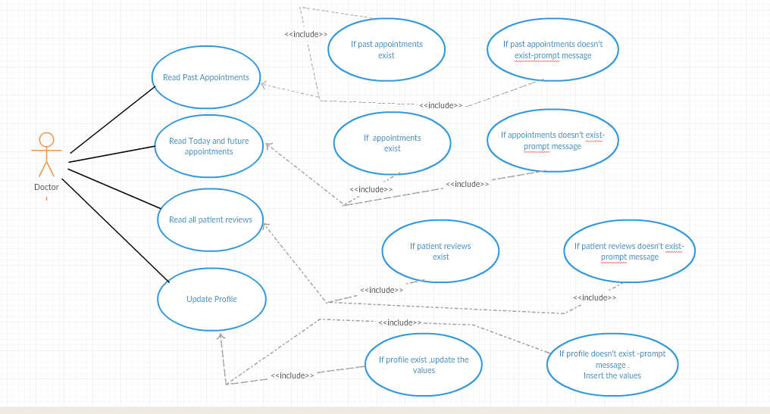

**ii) Patient use case diagram:**

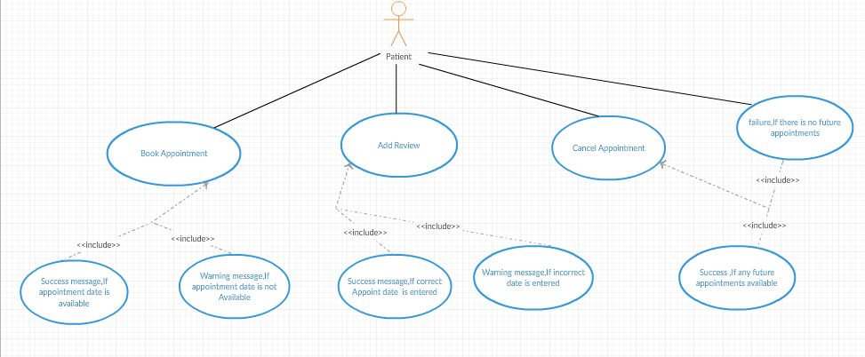

**2) Patient-Doctor Entity_Relation Diagram:**

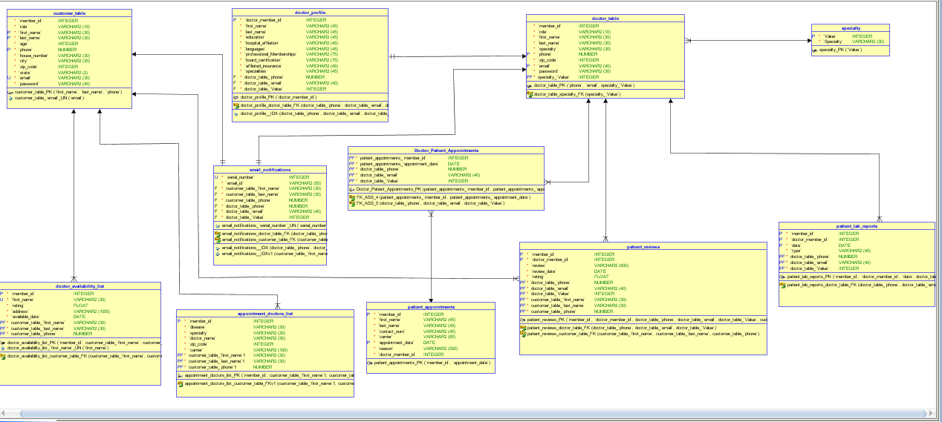

**2) Sequence diagrams**

**i) Doctor Sequence Diagram**

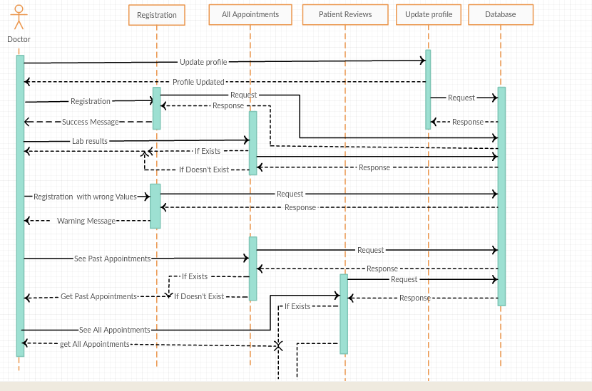

**ii) Patient Sequence Diagram:**

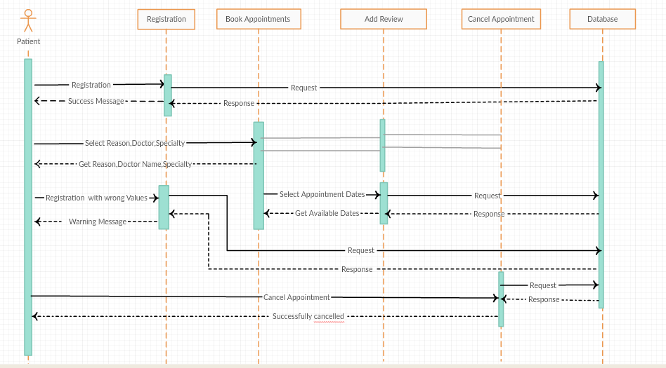

**Activity Diagrams**

**User Registration activity diagram:**

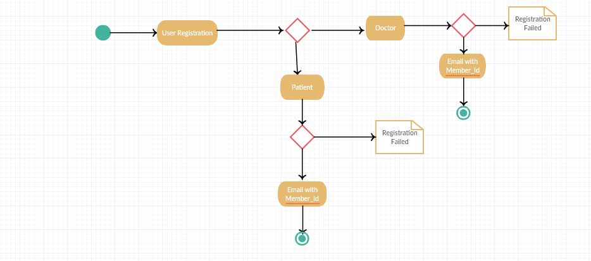

**Patient Activity diagram:**

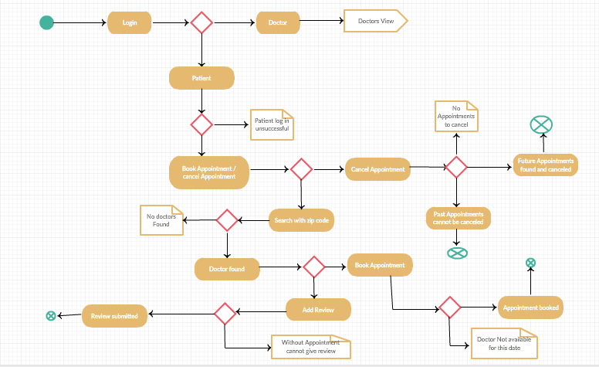

**Doctor Activity Diagram:**

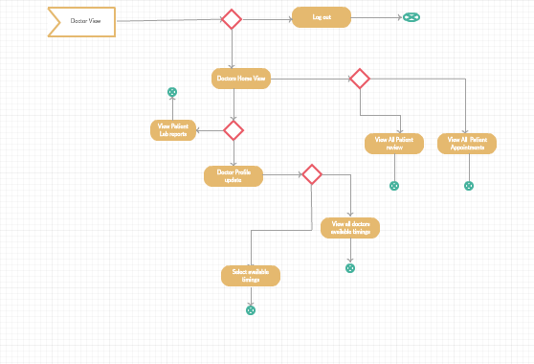

**Below are the Screen shots of the application:**

**Health Insurance Website Home page:**



**Contact Us page:**

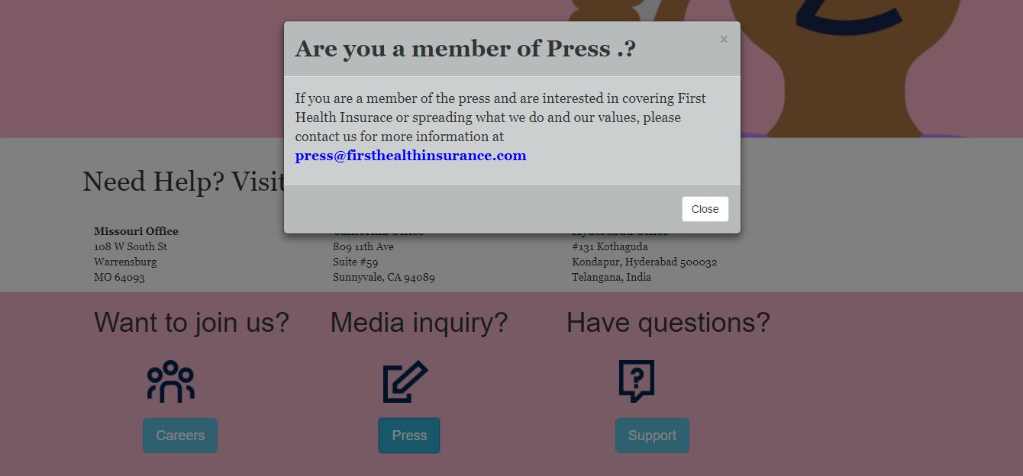

**Login Page:**

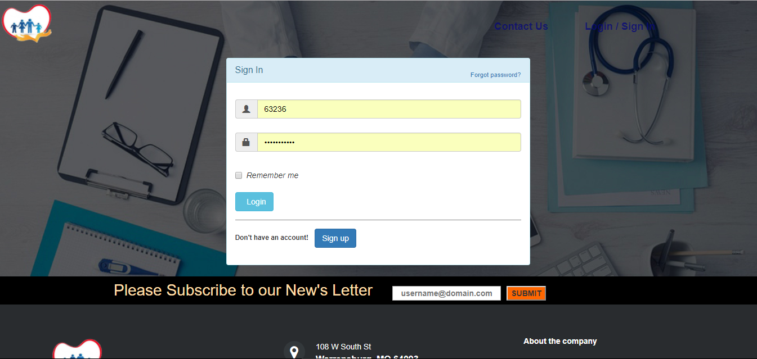

**Patient Registration page:**

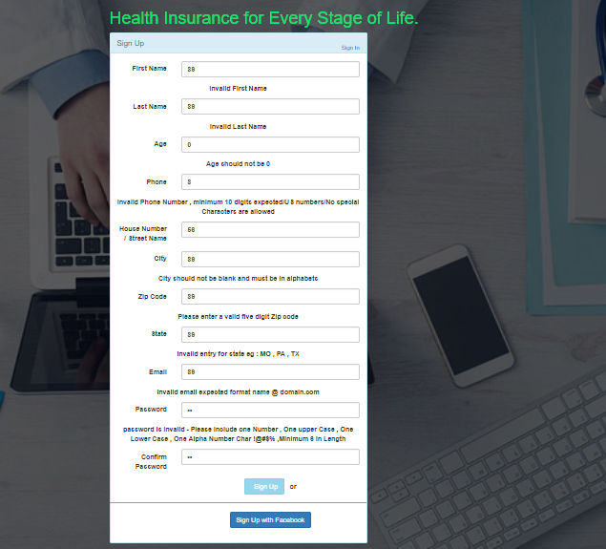

**Doctor registration page:**

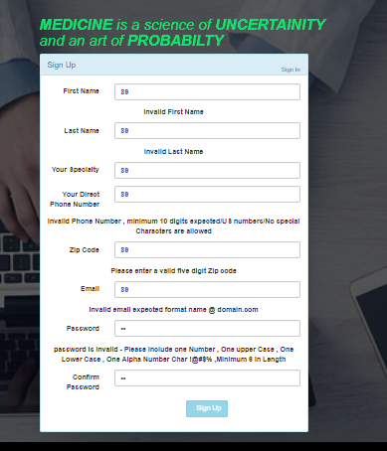

**Patient Home page:**



**Patient Invalid selection for doctors:**



**Patient Valid selection for doctors:**



**Patient checking doctor’s details:**

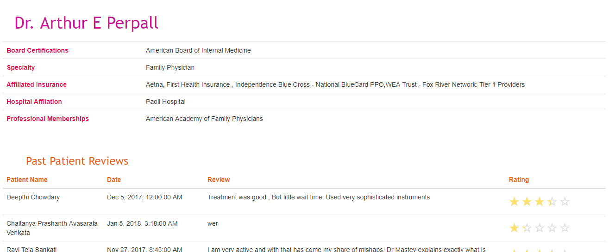

**Patient Appointment booking:**

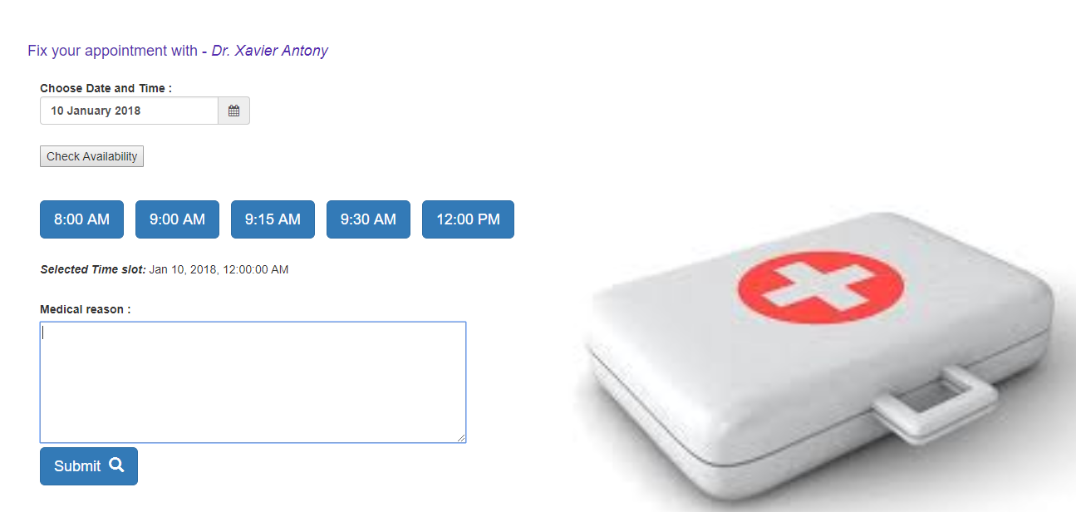

**Patient checking all appointments:**

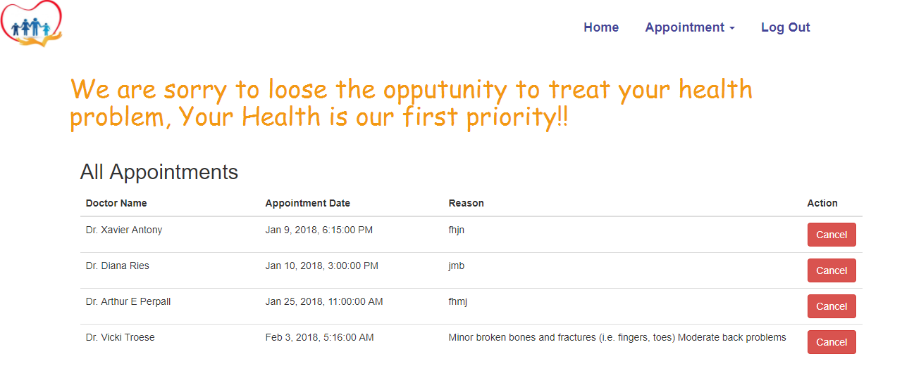

**Doctor Home page:**

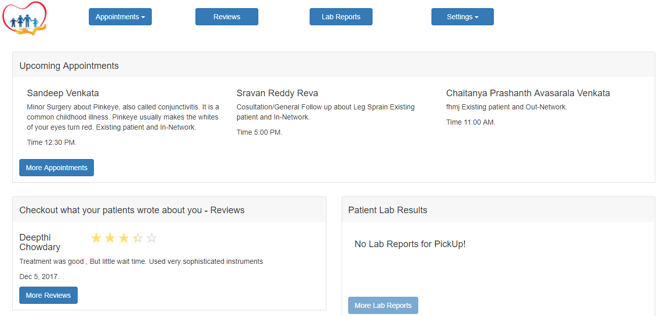

**Doctor profile update:**

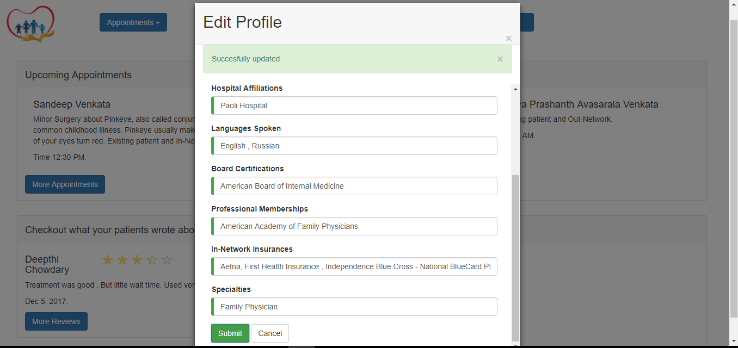

**Doctor Password update:**

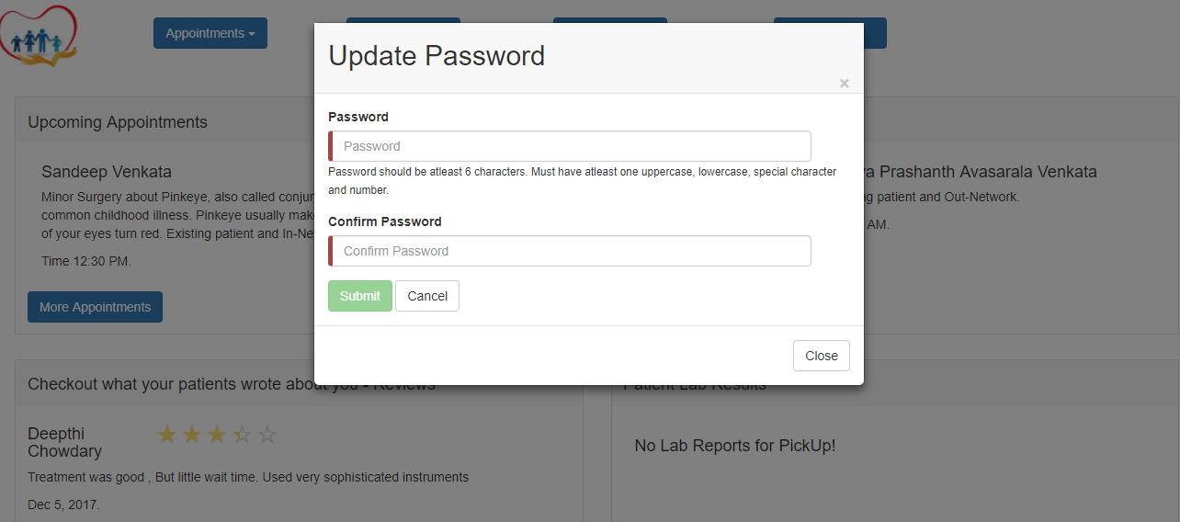

**Doctor Add availability:**

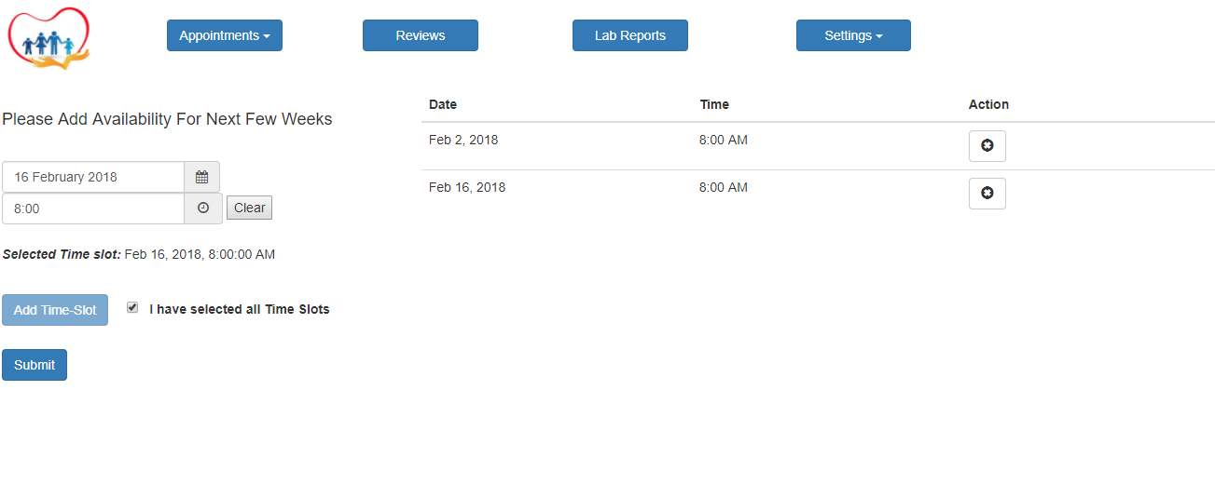

**Doctor checking all availability:**

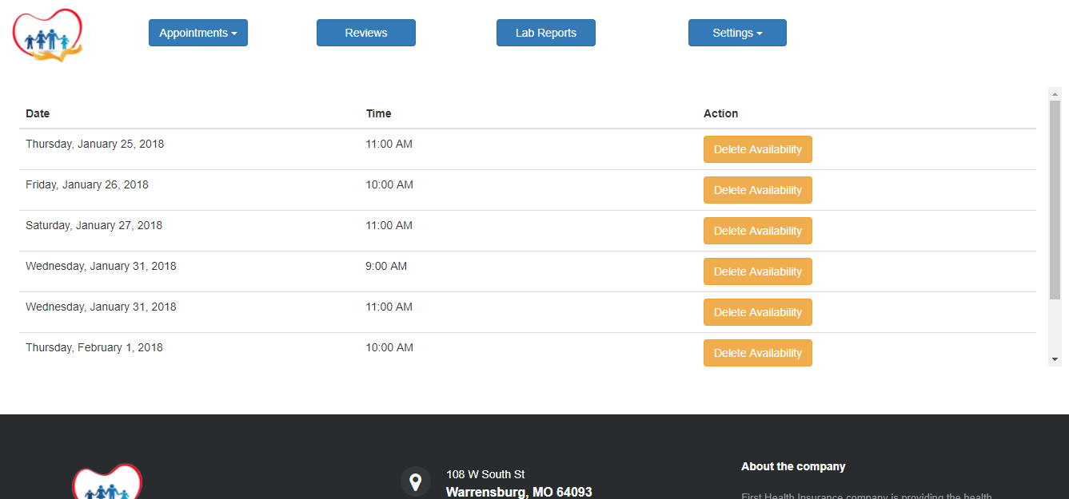

**Email newsletter subscription:**

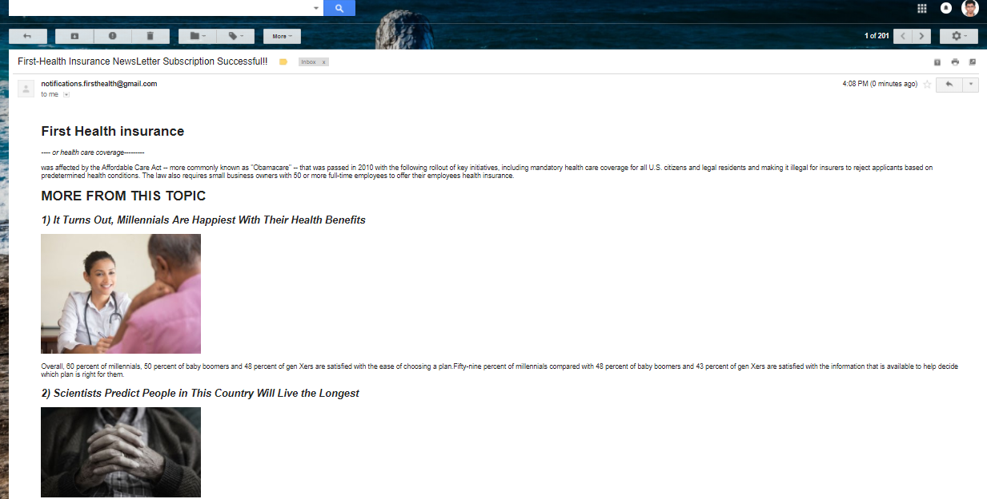

**SQL Queries used in REST web service apis:**

**1) Registering patient:**

**Query =** "INSERT INTO customer_table VALUES (?,?,?,?,?,?,?,?,?)"

**2) Registering Doctor :**

**Query =** "INSERT INTO doctor_table VALUES (?,?,?,?,?,?,?,?,?)"

**3) Fetching user profile :**

**Query =** "SELECT * FROM customer_table WHERE member_id = ? AND password = ?"

**Query =** "SELECT * FROM doctor_table WHERE member_id = ? AND password = ?"

**4) Fetching Doctor profile with member_id**

**Query =** "select * from doctor_availability_list where member_id IN (SELECT member_id

FROM appointment_doctors_list where zip_code = ? OR ( disease = ? OR specialty = ?

OR doctor_name = ?))"

**5) Fix Patient Appointment**

**Query =** "select * from patient_appointments where member_id = ? and doctor_member_id = ?"

**Query =** "update patient_appointments set carrier = ? ,appointment_date = ? , reason = ? where

member_id = ? "+ "and doctor_member_id = ?"

**6) Add Review For Doctor**

**Query =** "select * from patient_reviews where member_id = ? and doctor_member_id = ?"

**Query =** "update patient_reviews set review = ? ,review_date = ? , rating = ? where

member_id = ? " + "and doctor_member_id = ?"

**Query** = "insert into patient_reviews values (?,?,?,?,?)"

**7) Delete Appoint**

**Query =** "DELETE FROM patient_appointments WHERE member_id = ? AND

doctor_member_id = ? "

**8) Update Doctor Profile**

**Query =** "UPDATE health_db.doctor_profile SET first_name=?, last_name=?, education=?,

hospital_affliation=?, languages=?, professional_Memberships=?,

board_certification=?, affliated_insurance=?, specialities=? WHERE

doctor_member_id=?"

**Reference or Help Log:**

**For Activity , Sequence , Use case , E-R diagrams , CORS(Cross origin resource sharing) , Json ,**

**Angular 4, Bootstrap 3.3.7, Java 7.**

**Restful web services.**

* <https://creately.com/diagram/jaj29q561/E4sMexhDgakmqTgzqs67uSjQMk%3D>
* **https://creately.com/diagram/javdbba01/YI6onvxRqS4CIBKxsbBg97Yqq3w%3D**
* [**https://creately.com/app/?diagid=jaj8h1zh#**](https://creately.com/app/?diagid=jaj8h1zh)
* **https://creately.com/diagram/jc5jst681/XFORWRNGsQ1HyVYzHDLoXa1JW4s%3D**
* **http://restlet.com/blog/2015/12/15/understanding-and-using-cors/**
* [**http://restlet.com/blog/2016/09/27/how-to-fix-cors-problems/**](http://restlet.com/blog/2016/09/27/how-to-fix-cors-problems/)
* [**https://www.w3.org/TR/cors/**](https://www.w3.org/TR/cors/)
* [**https://developer.mozilla.org/en-US/docs/Web/HTTP/CORS**](https://developer.mozilla.org/en-US/docs/Web/HTTP/CORS)
* [**http://www.restapitutorial.com/httpstatuscodes.html**](http://www.restapitutorial.com/httpstatuscodes.html)
* [**https://stackoverflow.com/questions/4687271/jax-rs-how-to-return-json-and-http-status-code-together**](https://stackoverflow.com/questions/4687271/jax-rs-how-to-return-json-and-http-status-code-together)
* **https://stackoverflow.com/questions/37052617/how-to-deal-with-http-status-codes-other-than-200-in-angular-2**
* [**https://coderwall.com/p/ewxn9g/storing-and-retrieving-objects-with-localstorage-html5**](https://coderwall.com/p/ewxn9g/storing-and-retrieving-objects-with-localstorage-html5)
* [**https://stackoverflow.com/questions/20742922/can-a-table-have-multiple-primary-keys**](https://stackoverflow.com/questions/20742922/can-a-table-have-multiple-primary-keys)
* [**https://stackoverflow.com/questions/38283236/typescript-and-jquery-compile-error-cannot-find-name**](https://stackoverflow.com/questions/38283236/typescript-and-jquery-compile-error-cannot-find-name)
* [**https://samsaffron.com/blog/archive/2007/04/04/14.aspx**](https://samsaffron.com/blog/archive/2007/04/04/14.aspx)
* [**https://tutorialzine.com/2015/01/freebie-5-responsive-footer-templates**](https://tutorialzine.com/2015/01/freebie-5-responsive-footer-templates)
* [**https://w3layouts.com/medical-care-medical-category-bootstrap-responsive-web-template/**](https://w3layouts.com/medical-care-medical-category-bootstrap-responsive-web-template/)
* [**https://www.youtube.com/watch?v=NYZAwZ4rVqc**](https://www.youtube.com/watch?v=NYZAwZ4rVqc)
* [**https://www.npmjs.com/package/ng2-rating**](https://www.npmjs.com/package/ng2-rating)
* [**https://github.com/pleerock/ngx-rating**](https://github.com/pleerock/ngx-rating)
* [**https://nkalinov.github.io/ng2-datetime/**](https://nkalinov.github.io/ng2-datetime/)
* [**https://rawgit.com/ng2-ui/datetime-picker/master/app/index.html#/component-test**](https://rawgit.com/ng2-ui/datetime-picker/master/app/index.html#/component-test)
* [**https://developer.mozilla.org/en-US/docs/Web/JavaScript/Reference/Global_Objects/Date/toLocaleDateString#Checking_for_support_for_locales_and_options_arguments**](https://developer.mozilla.org/en-US/docs/Web/JavaScript/Reference/Global_Objects/Date/toLocaleDateString#Checking_for_support_for_locales_and_options_arguments)
* [**https://ng2.codecraft.tv/es6-typescript/mapset/**](https://ng2.codecraft.tv/es6-typescript/mapset/)
* [**https://regex101.com/r/iA5bT1/1**](https://regex101.com/r/iA5bT1/1)

**conclusion :**

End of this project ,I have gained knowledge in Angualr4 and Java Restful Web services , Boostrap.

Thorogh understanding of Angular4, type script concepts from Udemy and RestFul web services from Java brains(Kaushik) and successfully implemented this business idea.